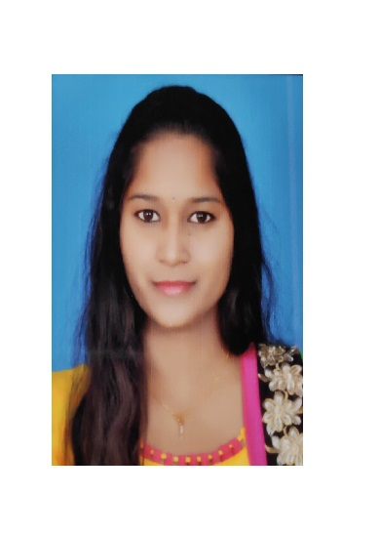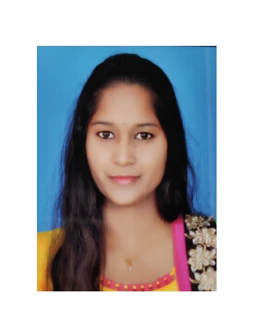

Electrical & Electronics Engineering

Percentage – 75%

Sree Venkateshwara College Of Engineering

Design & Implementation of Peltier Based Solar Powered Portable Refrigerator

Specify

Specify

Specify

Specify

ACADEMIC PROJECT

MATLAB / Simulink

C

Specfy Skills

ROSSELL TECHSYS (DIVISION OF ROSSELL INDIA LTD), Bangalore

Graduate Trainee Engineer

Johnson Controls India Pvt.Ltd (TYCO India), Bangalore.

To work in a challenging industrial environment that offers professional growth. While being resourceful, innovative and flexible. To make use of my skills to the maximum, to learn and to see my growth along with the growth of the organization.

yashu.p1402@gmail.com

Bangalore

M

Yasaswini Ponnaganti

CAD Engineer

OBJECTIVE

EXPERIENCE

EDUCATION

SKILLS

CAD Engineer

Kendriya Vidyalaya

PCMB

Nov 18 – Till Date

Feb 18 – Oct 18

2013 - 2017

2011 - 2013

Designing and Estimation of fire alarm system for commercial and industrial projects.

Preparing BOM, Process flow chart, Job Assembly Plan as per customer specification.

Percentage – 75%

AutoCAD

Pspice

+91 9036998037